Chapter 1

Problem Solutions

1.1
- fcc: 8 corner atoms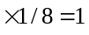atom
6 face atoms 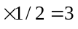atoms
Total of 4 atoms per unit cell
- bcc: 8 corner atomsatom
1 enclosed atom =1 atom
Total of 2 atoms per unit cell
- Diamond: 8 corner atomsatom
6 face atomsatoms
4 enclosed atoms = 4 atoms
Total of 8 atoms per unit cell
_______________________________________

1.2
- Simple cubic lattice: 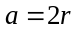
Unit cell vol 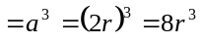
1 atom per cell, so atom vol 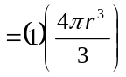
Then
Ratio 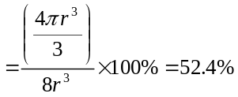
- Face-centered cubic lattice
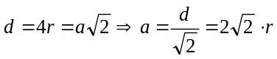
Unit cell vol 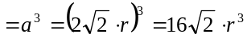
4 atoms per cell, so atom vol 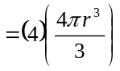
Then
Ratio 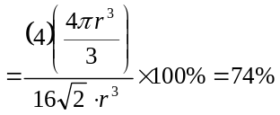
- Body-centered cubic lattice
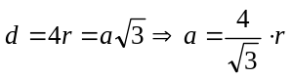
Unit cell vol 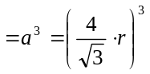
2 atoms per cell, so atom vol 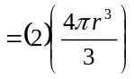

Then
Ratio 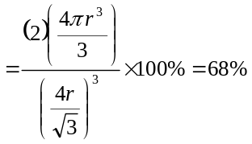
- Diamond lattice
Body diagonal 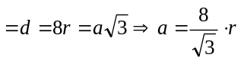
Unit cell vol 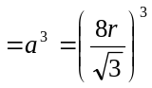
8 atoms per cell, so atom vol 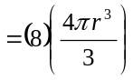
Then
Ratio 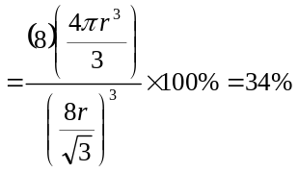
_______________________________________

1.3
- 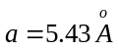; From Problem 1.2d,
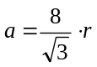
Then 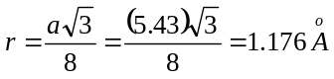
Center of one silicon atom to center of
nearest neighbor 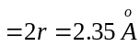
- Number density 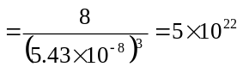cm
- Mass density
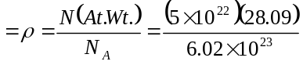
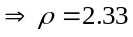 grams/cm
_______________________________________

1.4
- 4 Ga atoms per unit cell
Number density 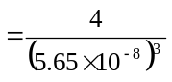
Density of Ga atoms 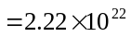cm
4 As atoms per unit cell
Density of As atoms cm
- 8 Ge atoms per unit cell
Number density 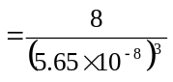
Density of Ge atoms 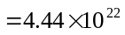cm
_______________________________________

1.5
From Figure 1.15
- 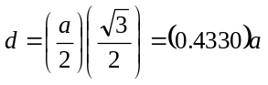
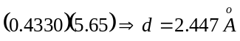
- 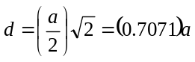
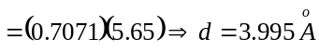
_______________________________________

1.6
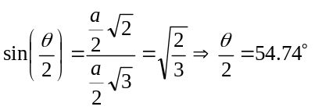
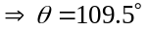
_______________________________________

1.7
(a) Simple cubic: 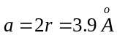
(b) fcc: 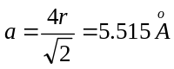
(c) bcc: 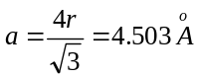
(d) diamond: 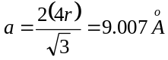
_______________________________________

1.8
- 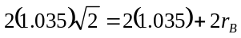
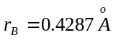

- 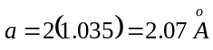
- A-atoms: # of atoms 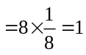
Density 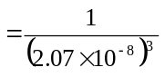
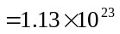cm
B-atoms: # of atoms 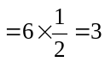
Density 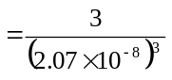
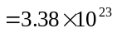 cm
_______________________________________

1.9
- 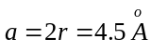
# of atoms
Number density 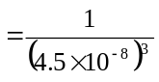
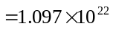cm
Mass density 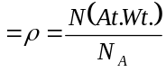
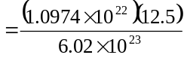
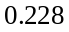gm/cm
- 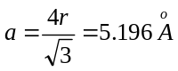
# of atoms 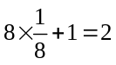
Number density 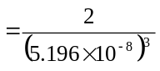
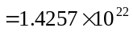cm
Mass density 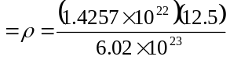
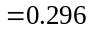gm/cm
_______________________________________

1.10
From Problem 1.2, percent volume of fcc
atoms is 74%; Therefore after coffee is
ground,
Volume = 0.74 cm
_______________________________________

1.11
(b)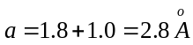
- Na: Density 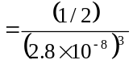
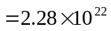cm
Cl: Density cm
- Na: At. Wt. = 22.99
Cl: At. Wt. = 35.45
So, mass per unit cell
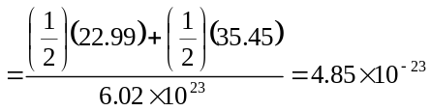
Then mass density
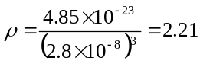 grams/cm
_______________________________________

1.12
- 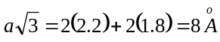
Then 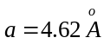
Density of A:
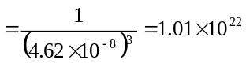cm
Density of B:
cm
- Same as (a)
- Same material
_______________________________________

1.13
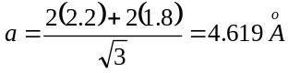
(a) For 1.12(a), A-atoms
Surface density 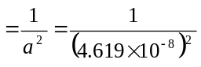
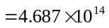cm
For 1.12(b), B-atoms: 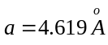
Surface density 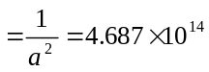cm
For 1.12(a) and (b), Same material

(b) For 1.12(a), A-atoms;
Surface density
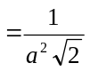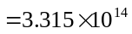cm
B-atoms;
Surface density
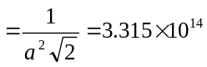cm
For 1.12(b), A-atoms;
Surface density
cm
B-atoms;
Surface density
cm
For 1.12(a) and (b), Same material
_______________________________________

1.14
- Vol. Density 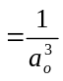
Surface Density 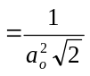
- Same as (a)
_______________________________________

1.15
- (110) plane
(see Figure 1.10(b))

(ii) (111) plane
(see Figure 1.10(c))

(iii) (220) plane 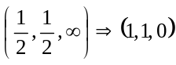
Same as (110) plane and [110] direction
(iv) (321) plane 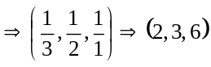
Intercepts of plane at
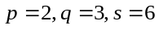
[321] direction is perpendicular to
(321) plane

_______________________________________

1.16
(a)
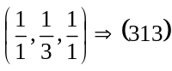
(b)
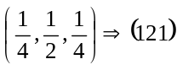
_______________________________________

1.17
Intercepts: 2, 4, 3 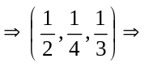
(634) plane
_______________________________________

1.18
- 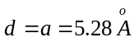
- 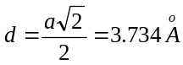
- 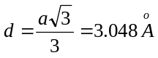
_______________________________________

1.19
- (a) Simple cubic
(i) (100) plane:
Surface density 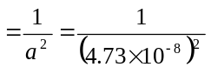
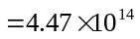cm
(ii) (110) plane:
Surface density
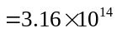cm
(iii) (111) plane:
Area of plane 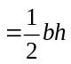
where 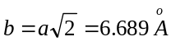
Now
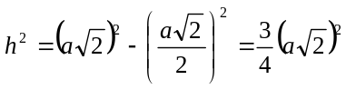
So 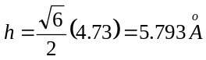

Area of plane
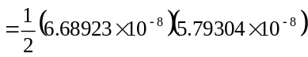
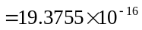cm
Surface density 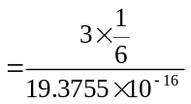
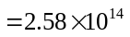cm
(b) bcc
(i) (100) plane:
Surface density 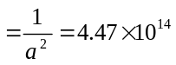cm
(ii) (110) plane:
Surface density 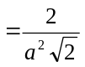
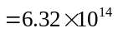cm
(iii) (111) plane:
Surface density
cm
(c) fcc
(i) (100) plane:
Surface density 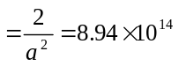cm
(ii) (110) plane:
Surface density
cm
(iii) (111) plane:
Surface density 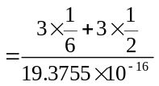
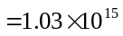cm
_______________________________________

1.20
- (100) plane: - similar to a fcc:
Surface density 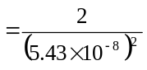
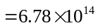cm
- (110) plane:
Surface density 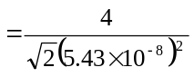
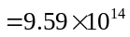cm

- (111) plane:
Surface density 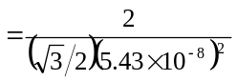
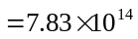cm
_______________________________________

1.21
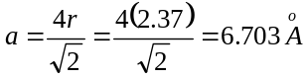
- #/cm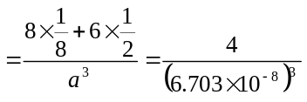
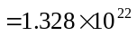cm
- #/cm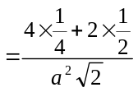
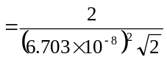
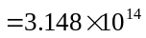cm
- 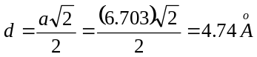
- # of atoms 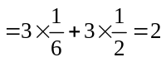
Area of plane: (see Problem 1.19)
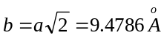
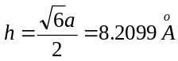
Area 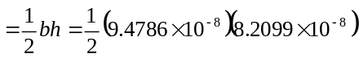
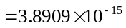cm

#/cm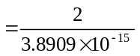
=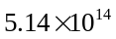 cm
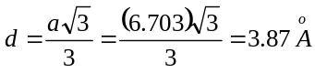
_______________________________________

1.22
Density of silicon atoms 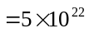cm and
4 valence electrons per atom, so
Density of valence electrons 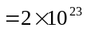cm
_______________________________________

1.23
Density of GaAs atoms
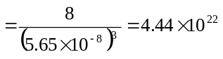cm
An average of 4 valence electrons per atom,
So
Density of valence electrons
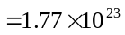cm
_______________________________________

1.24
- 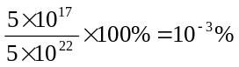
- 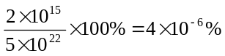
_______________________________________

1.25
- Fraction by weight
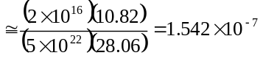
- Fraction by weight
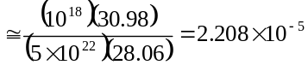
_______________________________________

1.26
Volume density 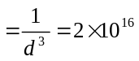cm
So 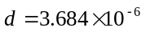cm 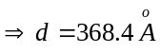
We have 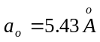
Then 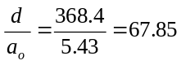
_______________________________________

1.27
Volume density 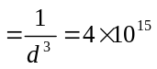cm
So 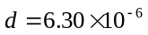cm 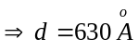
We have
Then 


